Today’s Lecture Road Map
Dated: 6th April 2021
Sensors and Sensor Ethics
- What is a sensor?
Anything that can detect information about the state of the device in the world around it
- Sounds
- Light (and vision)
- Movement
- Temperature / Humidity / Barometric Pressure
- Specialized (heartbeats, for example)
- Where is a sensor used?
Sensors originally were all specialized micro-devices and some were not so micro with their own API, custom hardware, etc.
It was a gigantic pain to get them to play together to do anything interesting which is changed in recent years with the advent of wireless sensor networks and Internet of Things.
- Where do we use sensors? [Automation]
- Construction installations
- Bridges
- Dams
- Oil Rigs
- Used for monitoring lots of big things that people couldn’t always get to
- military
- How a smart phone a Game changer?
One device with a BUNCH of sensors like Camera, Microphone, Accelerometer, GPS etc., all with one unified API and cheap.
- Persistent sensing
- Wearable computing
- eHealth
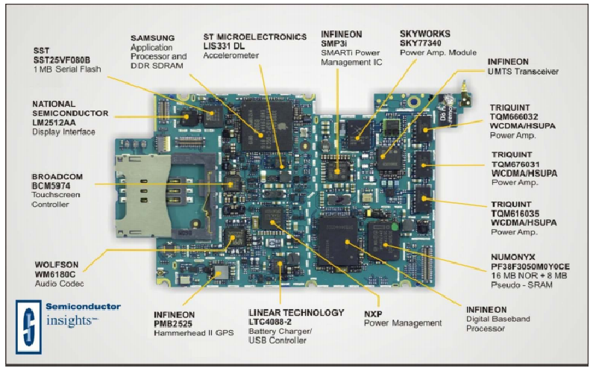
Image Copied*
  - What are the different types of sensors present on current smartphones?
    - Location Sensor (device location)
      - Wifi
      - Cellular
      - GPS
    - Position Sensor (device position)
- Orientation [Landscape /portrait]
- Proximity sensor
    - Motion Sensor (movement of device in multiple directions)
    - Gyroscope
    - Accelerometer
    - Environmental Sensors
    - Ambient Light
    - Altimeter
    - Barometer
- Sensor usage consideration
  - What these sensors do and how you can use them?
https://consumer.huawei.com/eg-en/support/content/en-us00685236/
For you interest: Sensor usage in Health Monitoring and diagnostic https://www.ncbi.nlm.nih.gov/pmc/articles/PMC6539461/
- Data
- What are you doing with the sensor data when you collect it?
- Is it only local, or is it transmitted to a server?
- Does it contain personally identifiable information?
- Is the data classified as protected in some way? (Medical, education, etc.)
- Is the data encrypted?
  - How long is the data stored
- Ethical Concerns
  - How bad can anyone be?
  - What worst can be done?
  - Ethics
    - Privacy: control over personal information
    - Consent: informed consent to participate in data collection
    - Equity: fairness and justice in how individuals are treated
    - Social forgetting: purposeful discarding of information to
      - enable forgiveness and a clean slate

Assignment: When does the benefit gained by utilizing sensors and gathering data outweigh any concerns for privacy, consent, equity, and social forgetting?
Read the scenarios highlighted in the reading: Ethical Issues in Participatory Sensing

